GARDEN OF EDEN KENYA - 2023 MID YEAR UPDATE
This has been a great first half of the year for us. Our lives have been busy but it is important to pause and recognize all that God has been doing through our ministry.
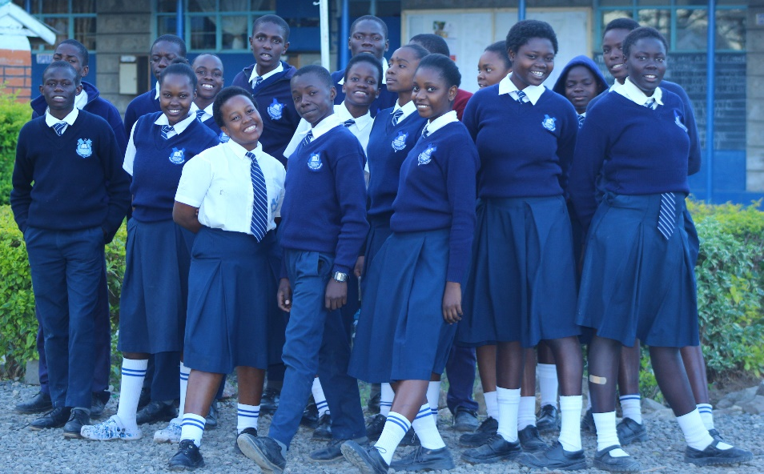
Children’s home: This year we had five of our children join high school, bringing the total number of high schoolers to twenty two. They are all liking the transition and enjoying a different school. They ride the bus to and from school every day from the children’s home. Two other children completed high school and will be joining college later this year.
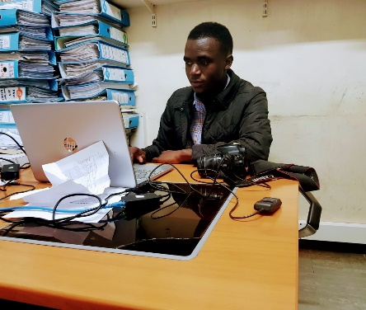
Austin, will be graduating college this year after four years of studying business. During his school he got the opportunity to do his practicum at Kenyatta national hospital which is the biggest referral hospital in East Africa. Prior to that he did another practicum at Kenya national Library in the procurement department.
Brenda underwent successful surgery to rectify her leg that had developed deformity after falling when she was about 8 years old. She is on the way to full recovery and is more confident and full of gratitude.
Our home has continued to attract government officials and community leaders who identify it for major functions in our region. We recently had a tree planting function that was led by the assistant county commissioner of Nairobi County.
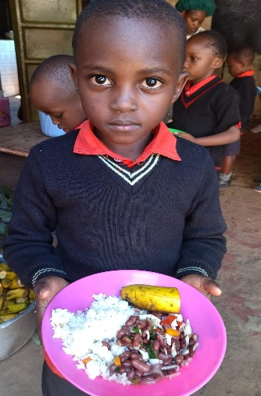
School: Being our 14th year of serving the children of Kibera slum, Savior King Education Centre is blessed to release well nurtured children to high school. This year 48 learners will sit their national exam in eighth grade and will be ready to join high school early 2024.
The school has also grown to be a community center that transforms lives through many different programs. Such as education, computer lab, library, women empowerment. Among our latest programs are:
Solar lights which enables kids who don’t have electricity in their houses to study and do their homework and helps them to improve their grades. The clinic helps kids and staff with minor sickness and first aid in case of injuries while in school. There is also an art center that helps our kids nurture their talents. The daycare has been a great help to both teachers and the community because it offers a safe place for babies to be cared for as their mothers go to look for daily bread.
Challenges: Apart from growth we have also found challenges; first it was due to COVID-19 then Ukraine and Russia war, as a country we also had prolonged drought which caused starvation and adversely affected our economy.
The high cost of living is now a big crisis because food and other essentials have become unaffordable for many people. Most foodstuff are imported from outside the country. All this has had a huge impact on our programs that feeds many children and takes care of many basic needs.
We thank God for all of you faithful supporters. Our prayer for you to experience abundance as you continue to send support and gifts that The lord uses to give hope to the children in need through our programs.
Blessings
Thomas & Beatrice.

